We downloaded monthly website clicks from the API into csv. File. Now, we need to find a way to compile such information and poll all the monthly data into a big sheet so that we can analyze it.

Failed way: I tried to make Excel to read from csv. files, but apparently one can only achieve it with Excel Macro. I don’t want to learn Macro just for this project, also the people using my data are not likely to have excel Macro. So, I decided to use python instead.

Python Approach:
I wrote a python script named: “Juntao Zhong Compiling data from Many Month Analytics”
The python code is attached here:
https://drive.google.com/drive/u/1/folders/1xMzMMWfA9vCjDFZ7LzcSsG-_V5DG0pkU

To use it, first, put all your monthly data into a folder, then on line 36: change the path to direct it to your data folder. Then, on line 55: set the path that the compiled csv. file will be created.
Line 31: it takes out the file path from the filename, so the column of csv. file don’t have file path information
The column names of the clicks are the names for the data file, so it’s important to name your data files as something that makes sense.
For example, I name my file 2017-01.csv for data between 2017 Jan. to 2017 Feb.

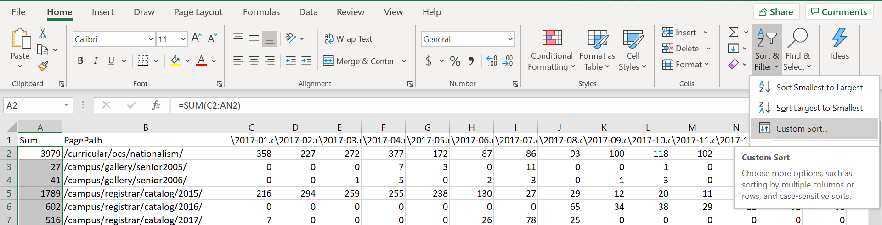
On the excel file, you can create a sum that sum up the total amount of clicks for that website for the past three years. Then, Custom sort it by various criteria: I’m sorting from smallest to biggest by Sum, then 2019 Dec., 2019 Nov., 2019 Oct. and finally 2019 Sept.
Also, for better visualization, I highlighted all the cells where the monthly click is 0 to yellow. So, you know no one has touch that website in that month.

